Name of Subject

ALIAS names

Order Type | CPPC ☐ OR SOC ☐ OR CPT ☐
Case Managed By | Please select where this case will be managed once approval is sought  NSD ☐ OR PDU ☐  (Please complete relevant section from rows below)
Probation Delivery Unit | Choose an item.
NSD Unit | Choose an item.
Police Escort Required | Please select the relevant option  YES ☐ NO ☐  Risks to Staff (Please include any known risk markers as outlined in OASys)
Order Start Date
Order End Date
EMS Case Number

Police Code Name
Subject Date of Birth

Subject Gender
Subject Address

Approved Premises contact number (if applicable)
Person on Tag mobile number | (This is needed to support recent alert changes)
Managing authority details, to be contacted by EMS in the event of a breach / incident (via phone) | Example:  Probation (09:00-17:00) In order of call out  INSERT OM NAME AND TELEPHONE NUMBER ( minimum 3 contacts)  If you have been unable to reach any of the contacts listed above, please contact the NSD Case administrator (during office hours) on _xxxx xxxx xxxx _ who will locate someone for you. Please be advised they will not be able to make any decisions related to the case, they will to take down the details of the issue and call back with the action needed.  Probation (17:00-09:00)  Out of hours - 07511405751  The use of “101” and “999” is not a viable option and will not be accepted as a reporting method**  Named contacts / arranging a police escort  Police (24 Hour Team) In order of call out  INSERT YOUR UNIT POLICE CONTACTS  NSD Heads and Senior Operational Lead’s;  NSD North  Head - Shona Drummond –Shona.Drummond@justice.gov.uk  SOL - Racheal Taylor - RachaelC.Taylor@justice.gov.uk  SOL - Tom Simpson –  Tom.Simpson@justice.gov.uk  SOL - Sarah Wylie –  Sarah.Wylie@justice.gov.uk  SOL – Natalie Owen –  Natalie.Owen@justice.gov.uk  NSD Wales & SW  Head - Jay Ali –  Jay.Ali@justice.gov.uk  SOL – James Beazley – James.Beazley@justice.gov.uk  SOL – Lewis Gittins  Lewis.gittins1@justice.gov.uk  SOL – Ashleigh De’ath -  Ashleigh.Death@justice.gov.uk  NSD Midlands  Head – Amy Thornton –  Amy.thornton1@justice.gov.uk  SOL – Matthew Sharp - Matthew.Sharp@justice.gov.uk  SOL – Sadie Howard –  Sadie.Howard@justice.gov.uk  NSD E & SC  Head - Katharine Rogers –  Katharine.Rogers@justice.gov.uk  SOL – Lewis Firman –  Lewis.Firman@justice.gov.uk  SOL – Marina Moran –  Marina.Moran@justice.gov.uk  NSD London & KSS  Head - Gillian O’Brien -  Gillian.OBrien@justice.gov.uk  SOL - Julie Hall –  Julie.Hall1@justice.gov.uk  SOL – Jess Shapland  Jess.Shapland@justice.gov.uk  Head of Central projects Team - Sarah Jones  Sarah.jones7@justice.gov.uk  SOL – Jane Powell –  Jane.Powell@justice.gov.uk
Managing authority details, to be contacted by EMS in the event of a breach / incident (via email) | Email Address -  (Please note that should you receive an email alert, you must respond to the alert by 10am the next/same working day OOH; Action required, or No Further Action)
Context of Electronic Monitoring | This protocol has been prepared for the above named person who will be subject to Electronic Monitoring as operated by EMS under provisions of his licence conditions.
Conditions affecting Electronic Monitoring | - To permit himself/herself to be fitted with and shall thereafter at all times wear an electronic monitoring tag by EMS.  2. Upon the service of the licence the individual must remain at the Designated Premises for an overnight period each day.  3. To permit entry to the Designated Premises by police officers at any time for the purpose of identifying the individual’s presence or monitoring compliance with any condition of the licence.  4. To permit access to EMS for the purpose of installing, inspecting, checking, maintaining, repairing and (if and when removal becomes appropriate) removing equipment at the Designated Premises to enable or facilitate electronic monitoring carried out by EMS.  5. EMS staff must always be escorted by a police officer when visiting the premises of a person subject to a licence.  - Please include a copy of the subject’s licence (including a clear photo) along with this protocol.  Please add further conditions if applicable.
Interpreter Requirements
Health Requirements

Telephone Reporting Arrangements
Monitoring Type | GPS tag & Monitoring Unit
Curfew Schedule | The individual must remain in their residence between the following hours daily:  00:00hrs to 00:00hrs  The above curfew will be monitored by EMS  *Does/Does not include garden access*
Inclusion and Exclusion Zones | Exclusion / Zone Details:  (Please include maps of Inclusion and Exclusion Zones along with this protocol)
Inclusion and Exclusion Zones | Add Standard Exclusion Zones  (airports, ports and train stations)  Please see Annex A list of zones – Should you wish to de-select any of the zones due to residency/appointments being within any of the zones, please specify which zone below utilising the list provided.  YES ☐ NO ☐  Standard Zones to be excluded:  Add London Exclusion Zones  City of London, City of Westminster and London Borough of Southwark (OR Sectors 1-7 for London based cases)  YES ☐ NO ☐
Trail Monitoring | Is Trail Monitoring a requirement?  This involves monitoring an offender’s movements to support discussions with their offender manager about lifestyle and behaviours  YES NO
Other Conditions:

Breach/Progress Report Contact: | Probation Offender Manager/ Managing Police Team Emails:
Electronic Monitoring Contact | Serco Electronic Monitoring  Dornoch House  Warrington  emCCSpecialCase@ems.co.uk
MOJ Electronic Monitoring Contact | Contract Management Team at Ministry of Justice  EMServiceManagers@justice.gov.uk

Annex A – List of Standard Exclusion zones
Standard Zone Type | Name of Standard Zone | Zone Size
Airports | Aberdeen Airport | 5000m
Airports | Belfast City | 5000m
Airports | Belfast International (Aldergrove) | 5000m
Airports | Birmingham International | 5000m
Airports | Bournemouth International | 5000m
Airports | Bristol | 5000m
Airports | Cardiff | 5000m
Airports | East Midlands | 5000m
Airports | Edinburgh | 5000m
Airports | Exeter | 5000m
Airports | Gatwick | 5000m
Airports | Glasgow | 5000m
Airports | Heathrow | 5000m
Airports | Leeds and Bradford International | 5000m
Airports | Liverpool | 5000m
Airports | Luton | 5000m
Airports | Manchester | 5000m
Airports | Newcastle | 5000m
Airports | Southampton International Airport & Southampton Docks & Cruise Yerminal | 5000m
Airports | Southend | 5000m
Airports | Stanstead | 5000m
Airports | London City Airport | Zone covers the airport (see map below)
Airports | Biggin Hill Airport | 5000m
Airports | Blackpool Airport | 5000m
Airports | City of Derry Airport | 5000m
Airports | Gloucestershire Airport | 5000m
Airports | Inverness Airport | 5000m
Airports | Newquay Airport | 5000m
Airports | Northolt Airport | 5000m
Airports | Norwich Airport | 5000m
Airports | Prestwick Airport | 5000m
Airports | Robin Hood Airport | 5000m
Ports | Belfast (Heysham & Liverpool terminals & Sea Cat Terminal) | 5000m
Ports | Cairnryan | 5000m
Ports | Dover | 5000m
Ports | Felixstowe | 5000m
Ports | Fishguard | 5000m
Ports | Harwich | 5000m
Ports | Heysham | 5000m
Ports | Holyhead | 5000m
Ports | Larne | 5000m
Ports | Pembroke | 5000m
Ports | Plymouth | 5000m
Ports | Poole | 5000m
Ports | Portsmouth | 5000m
Ports | Channel Tunnel (Longport / Cheriton) | 5000m
Ports | Dover Terminal 1 | 5000m
Ports | Dover Terminal 2 | 5000m
Ports | Dover Terminal 3 | 5000m
Ports | Dover Terminal 4 | 5000m
Ports | Dover Terminal 5 | 5000m
Ports | Dover Terminal 6 | 5000m
Ports | Dover Terminal 7 | 5000m
Ports | Merseyside 12 Quays / Docks | 5000m
Ports | Teesport | 5000m
Rail Stations | St Pancras International Rail Station | Zone covers the station (see map below)
Rail Stations | Ashford International Rail Station | 5000m
Greater London | Greater London Inclusion Zone | The zone covers the area within the M25

St Pancras Train Station
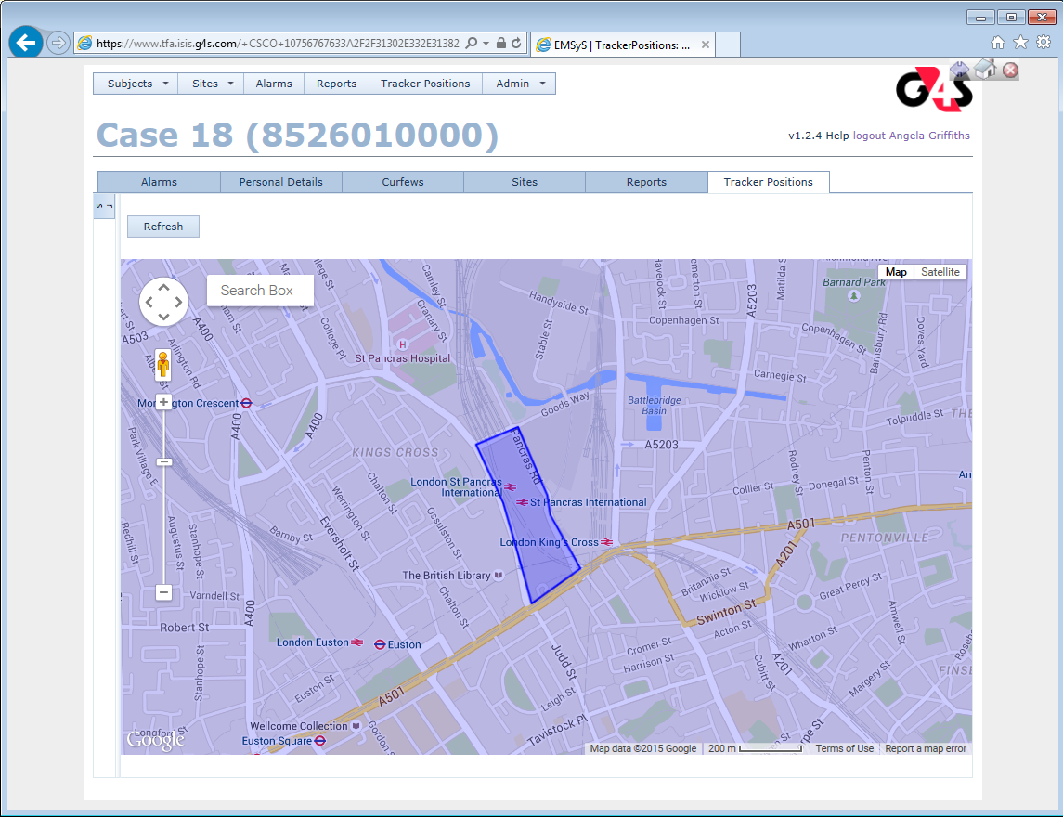
London City Airport
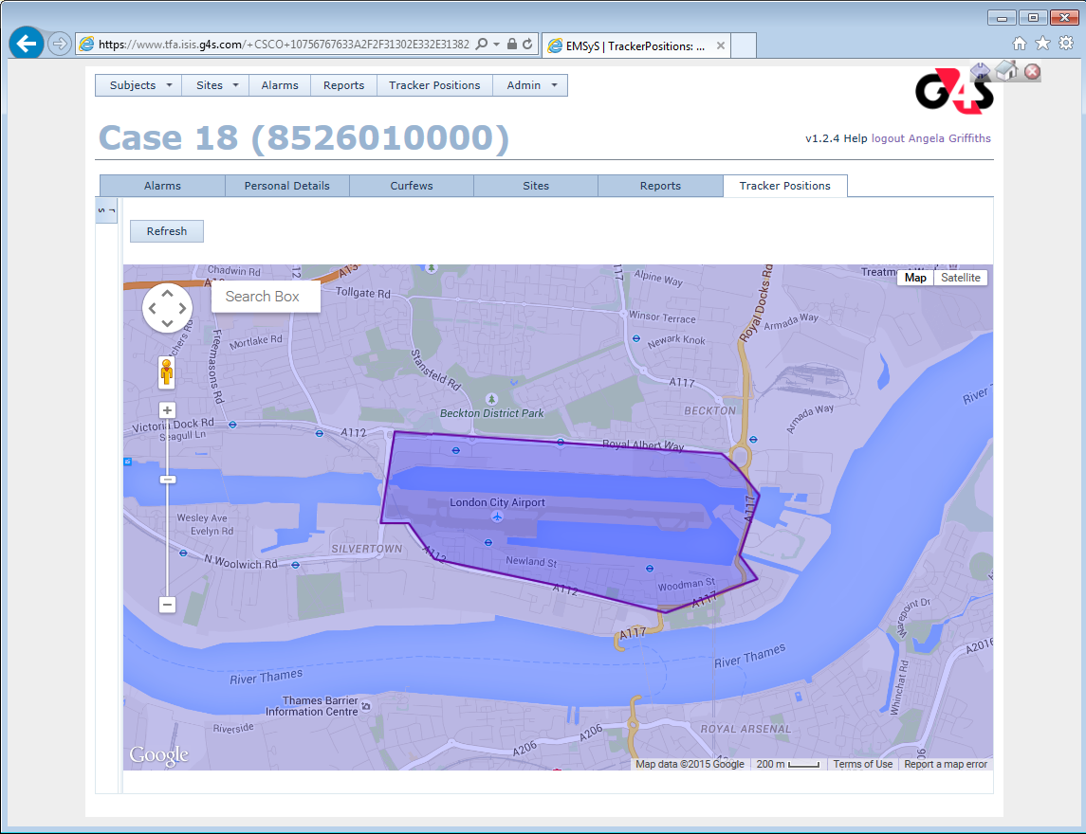
London City Airport

